**Hosting Static Website in an AWS S3 Bucket**

### Step 1

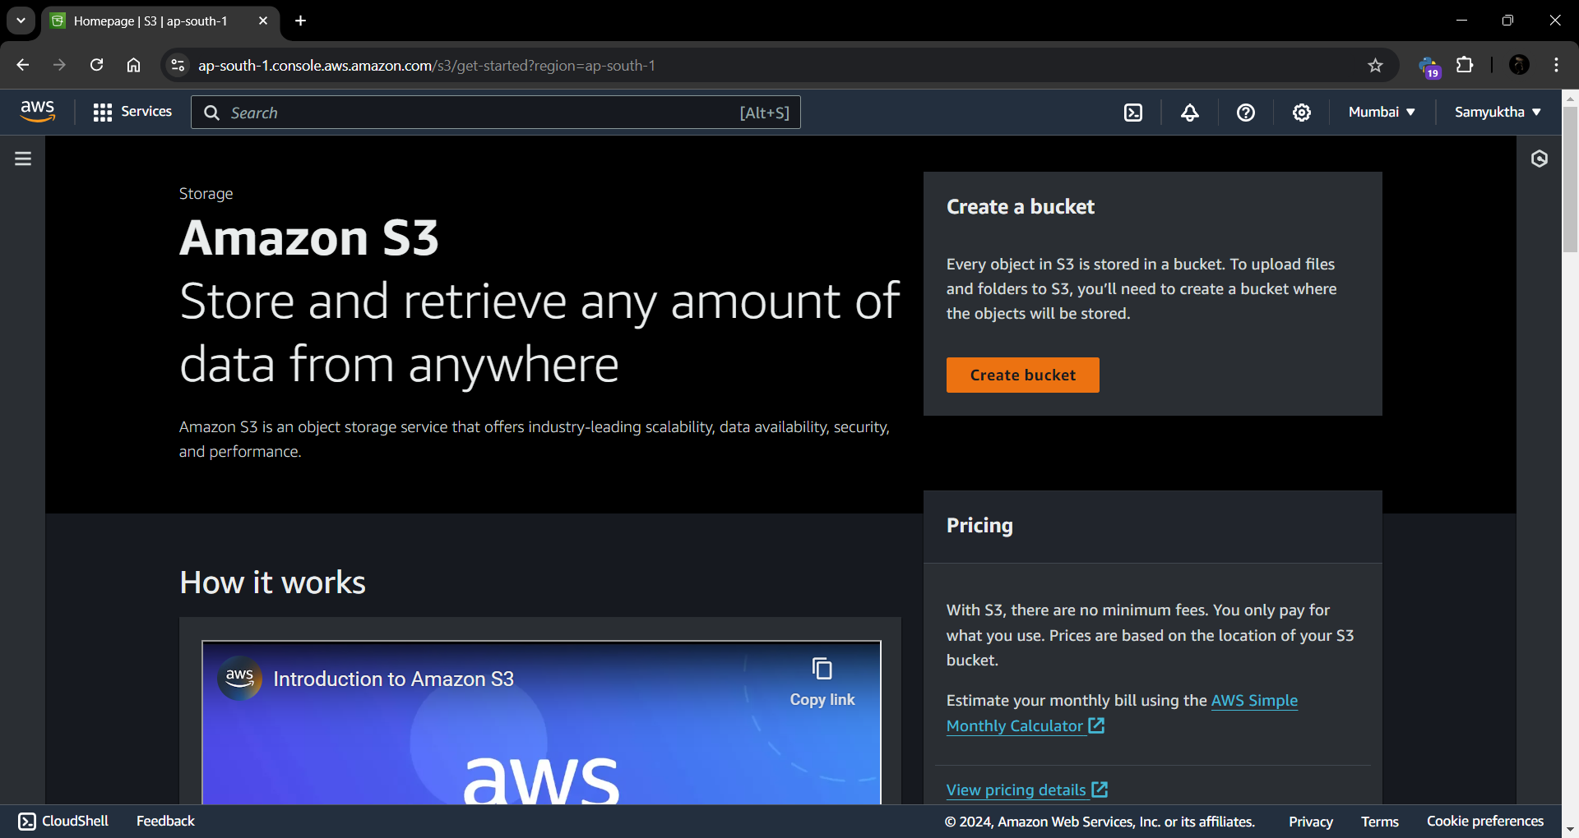

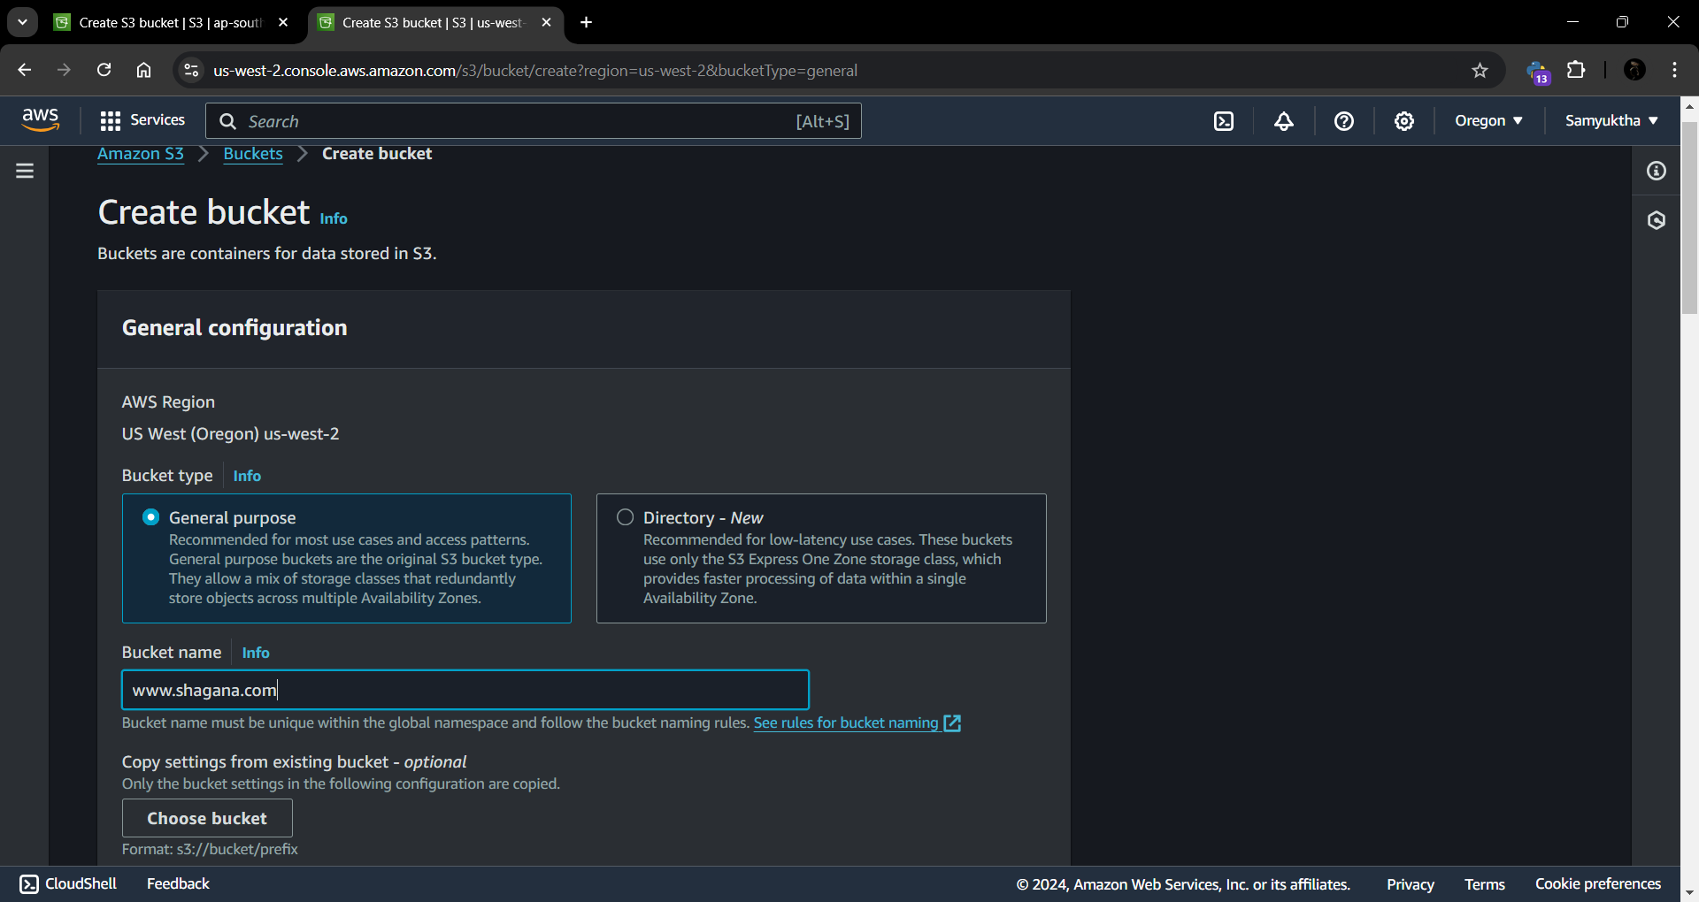

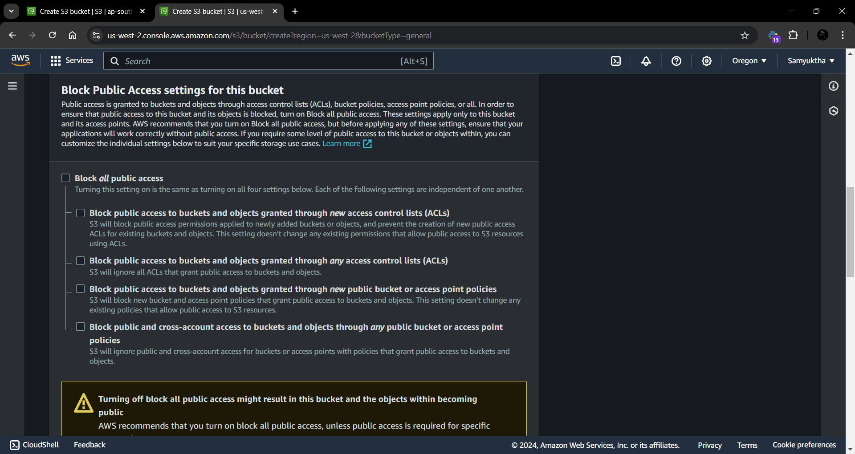

### Step 2 – Enabling Static Website Hosting

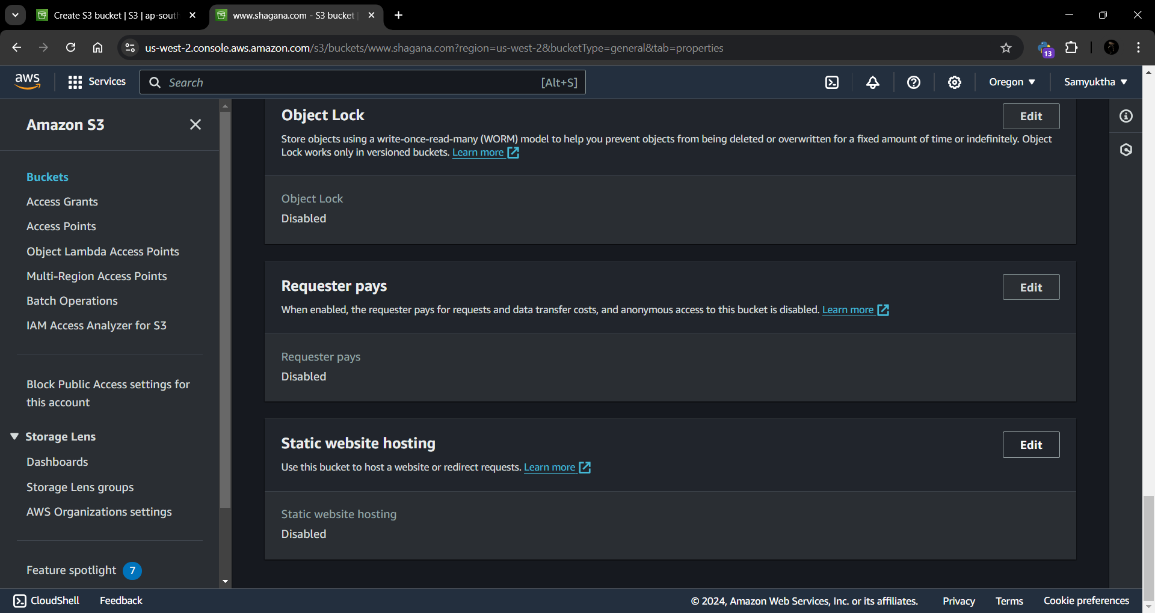

### Step 3 – Securing my S3 Bucket through IAM Policies

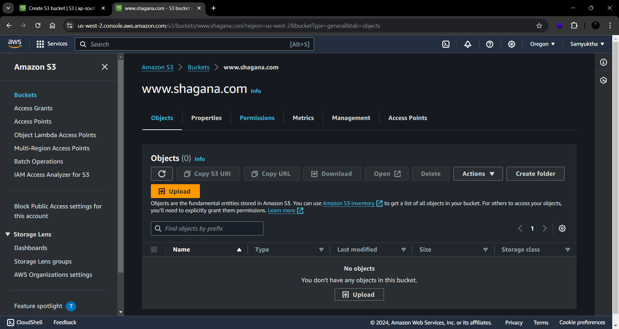

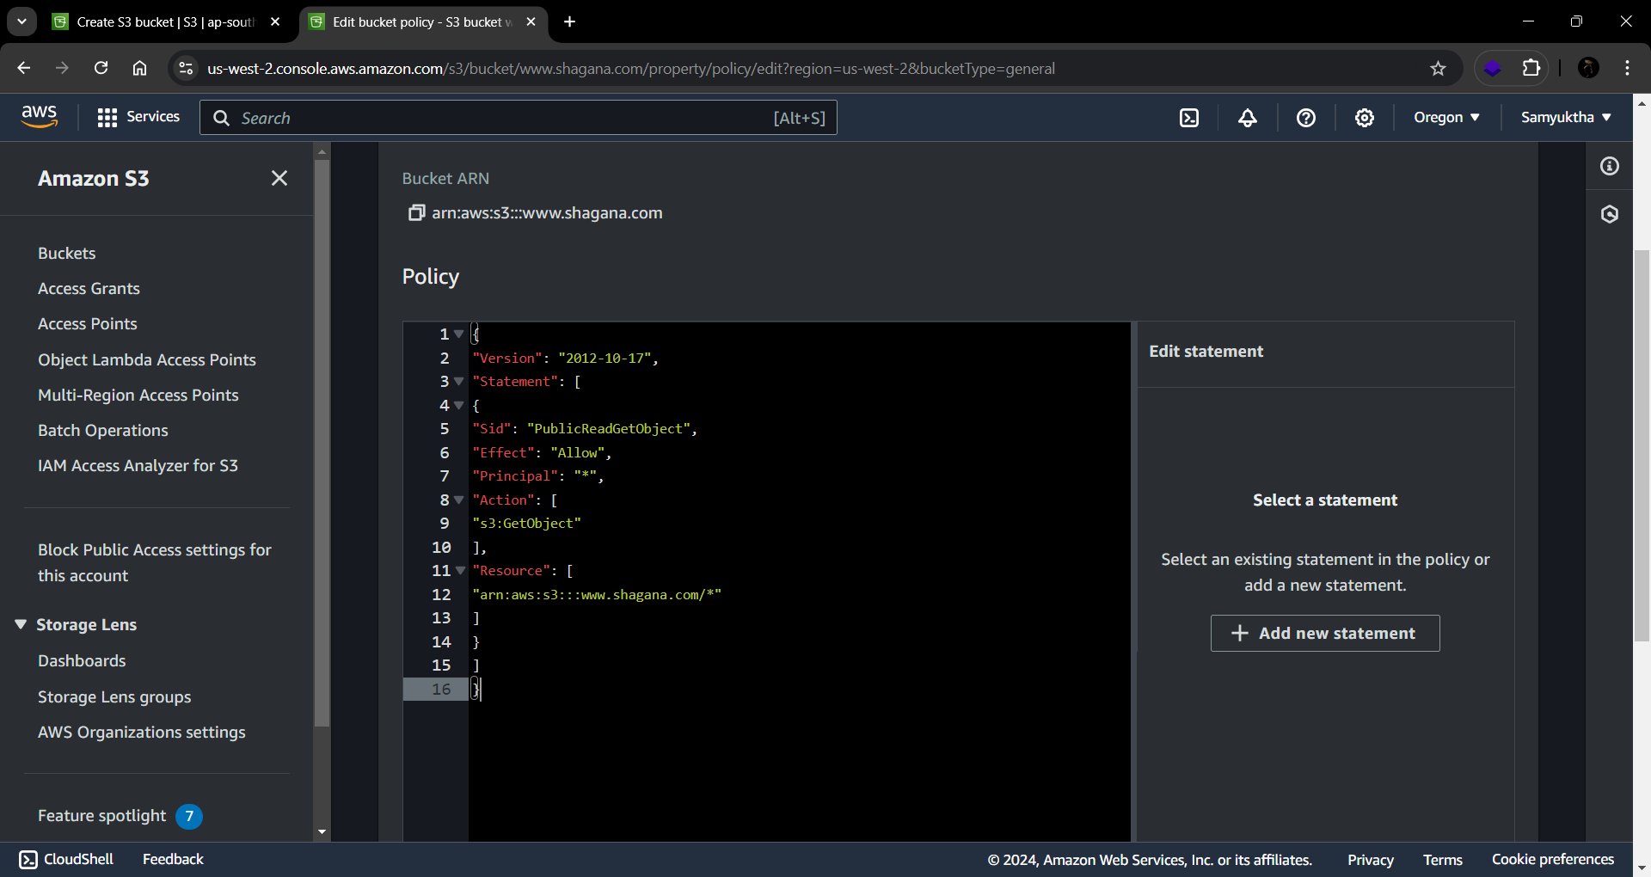

### Step 4 – Uploading Web Files to my S3 Bucket

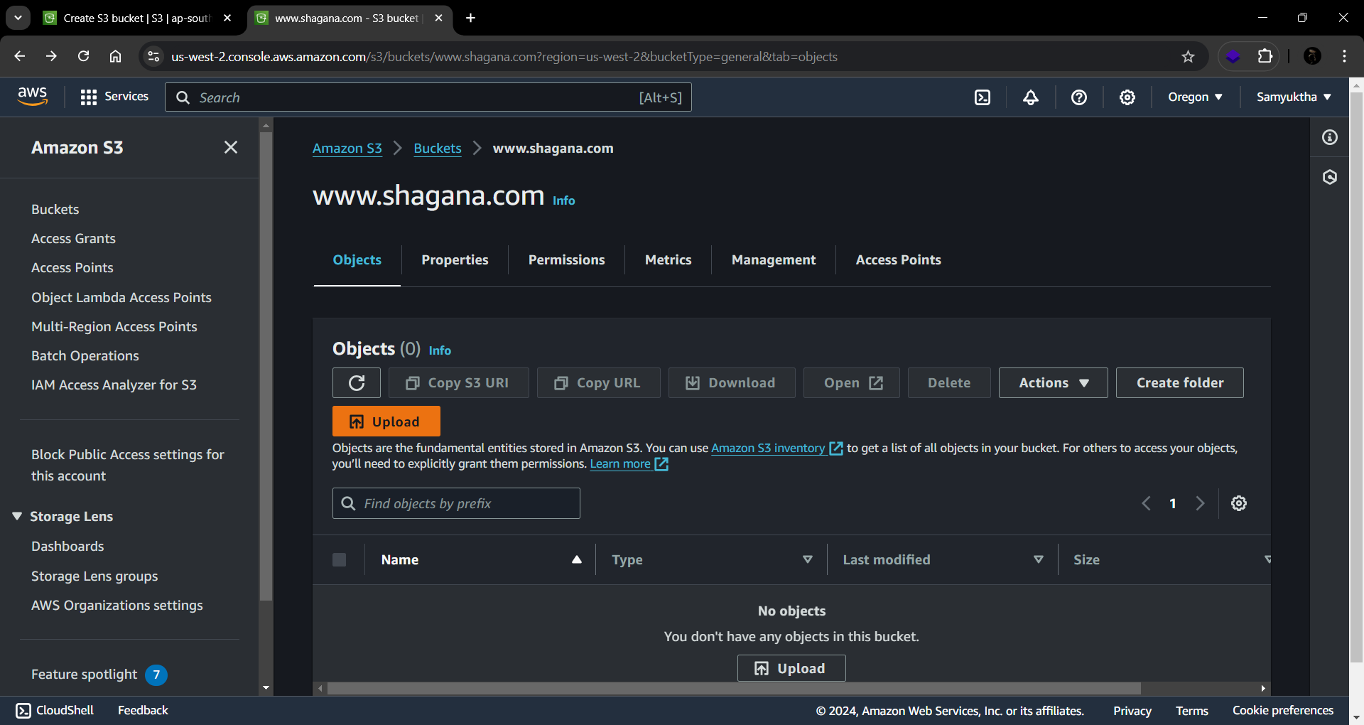

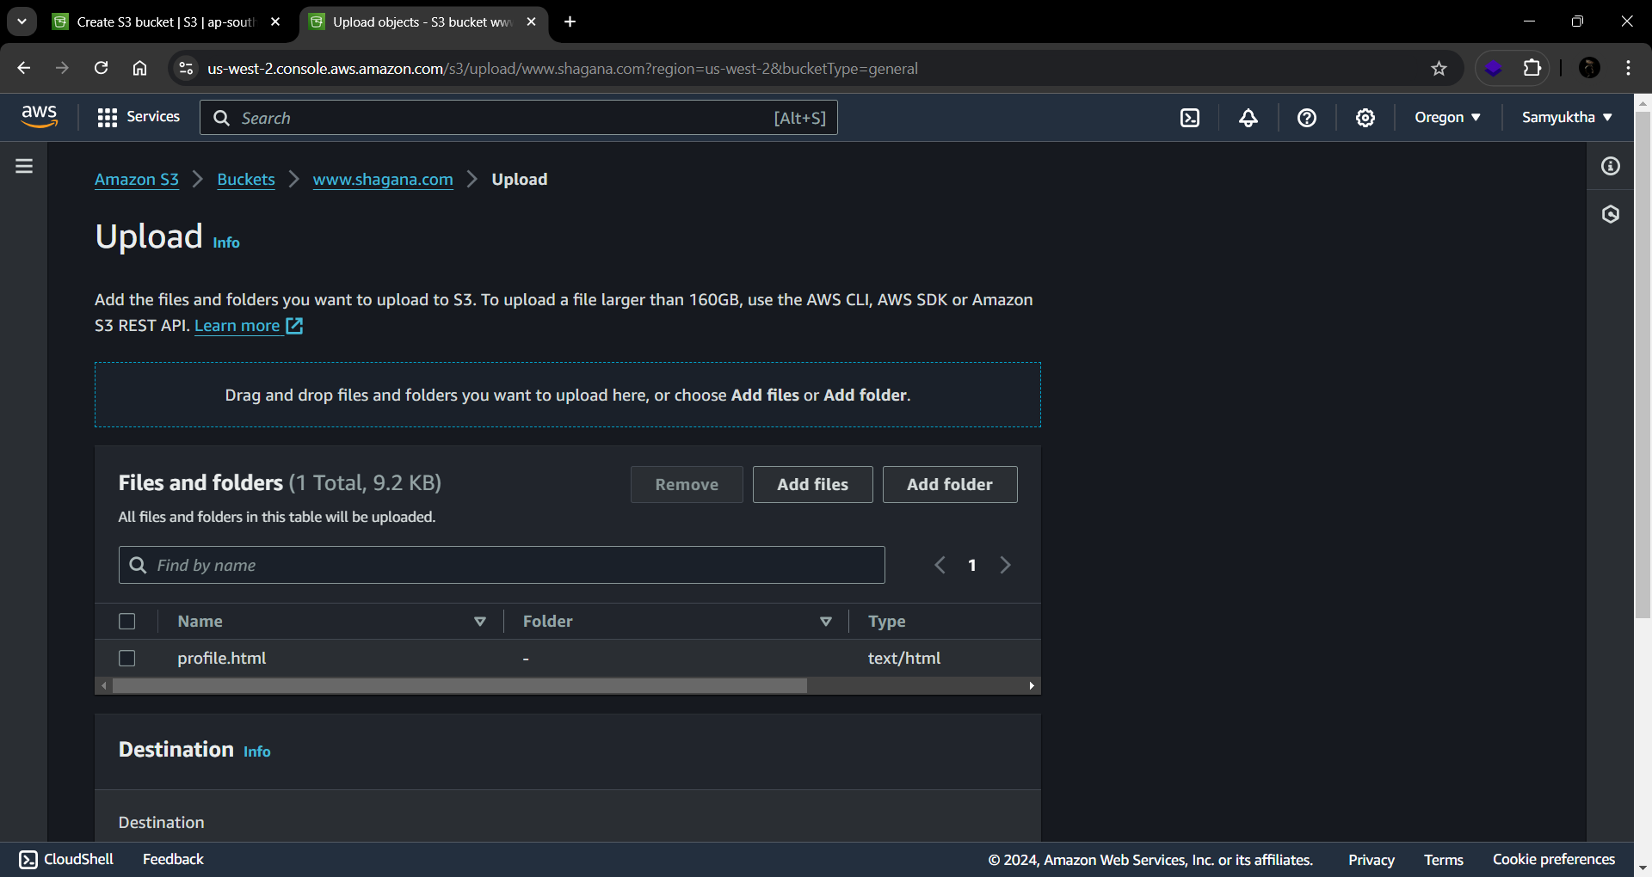

### Step 5 – Testing my website endpoint



